Dewm Game Design Document

Tyler Hodzen, Alan Harris, Nick Hadley, Eunbin, Seth Aitcheson

**Overall Vision for the Game**

The vision of this game is to try and replicate the fast and fun action of Doom, Quake, and similar games but in a 2D, side-scrolling, view. This is a game that will inspire heavily from Doom such as killing demons, collecting and using keycards to access different rooms, gore, metal, and fast-paced action. The priority for this game is fun; the player and weapons should feel powerful. If the player isn’t smiling, then that’s a bad sign.

**Platform**

The target platform is PC, using WASD and spacebar to move and using a mouse to aim.

**Genre**

The game’s genre is a 2D action platformer.

**Core Gameplay**

* **Core game mechanics**: core game mechanics consist of running, jumping, and shooting. There will be many enemies and projectiles on screen at a time, so having solid character control is very important. The movement will be tight, and the character will have a double-jump so that they have midair control, as well as a small i-frame dash to get through groups of enemies. The guns will be powerful, and the player will not need to reload, but the weapons can run out of ammunition.
* **Goals**: The main goal is to survive and get to the next level. Throughout the game, the player will need to find keycards to access certain doors to make progress, similar to games like Doom.
* **Components**: The game will have a variety of demonic enemies and traps that will try and kill the player. The player can use the weapons at his/her disposal (such as a pistol, shotgun, and assault rifle) to fight back. There may be secrets, powerups, and a scoring system as well, but those are not a priority.
* **Controls**: The control method that will be focused on is keyboard and mouse. The player will move around with WASD, (double-)jump with space, aim with the mouse, and shoot with left-click, as well as switching weapons with the scroll-wheel or numbers (1, 2, 3, etc.)
* **User experience**: Simplicity is key to this game. We want the players to feel comfortable with the controls at the start; just move and shoot. This game does not need cumbersome controls, intricate menus, or any kind of perk/leveling system. When the player starts the game, they should know their objective (killing demons and finding the keycards).

**Visual Style**

This is a 2D game that takes place in Hell. The game should look dark, gritty, and atmospheric, using a dark color-palette while using bright colors to emphasize certain things (ex: bright red blood).

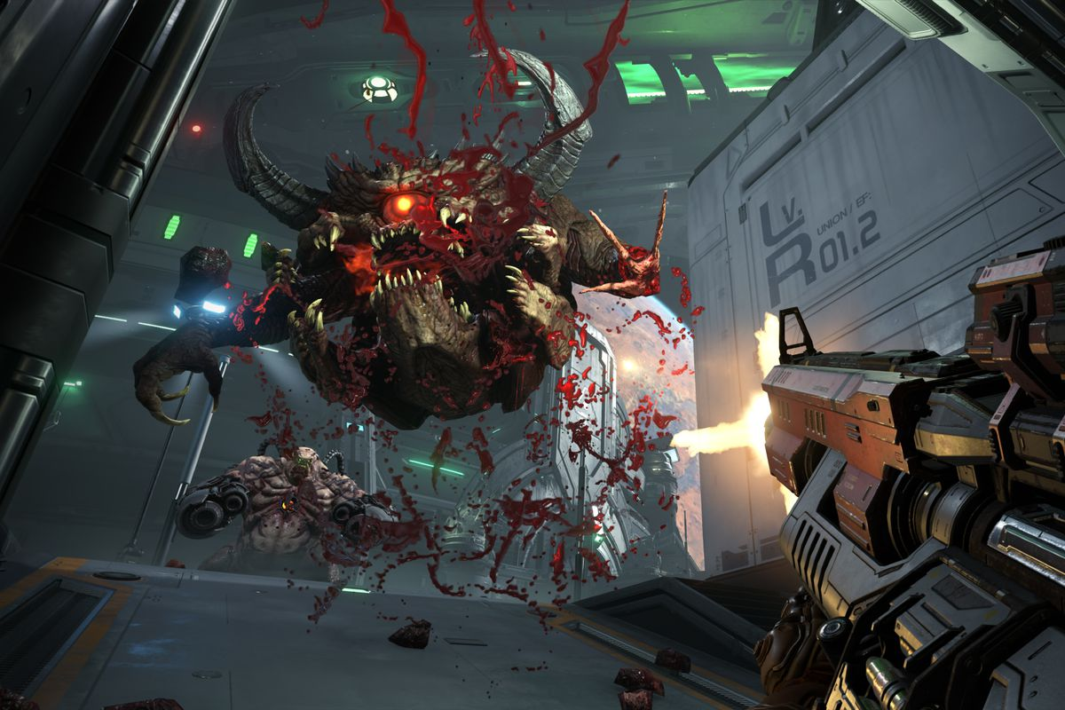

Ewww, look at that blood. Also, what a scary demon!

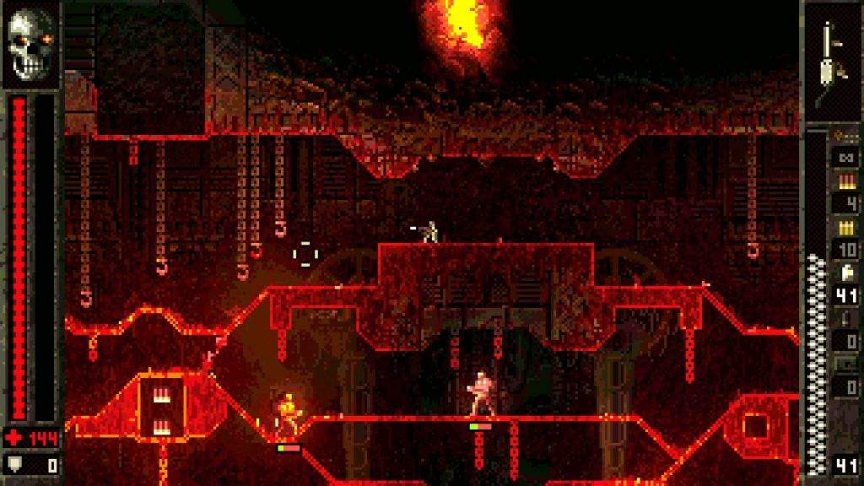

Check out that atmosphere. Dark and moody. Neat.

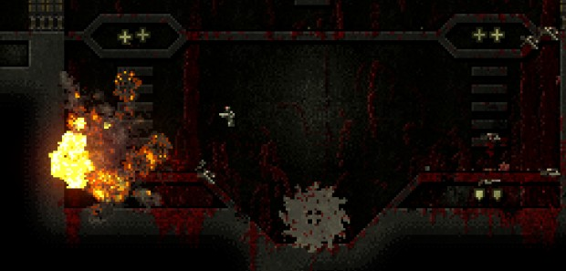

Is that blood on the ground? That’s nasty. And a buzzsaw?!

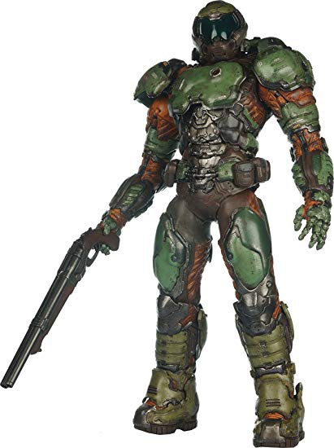

This is you! The player character is just some dude in a suit, nothing special. Was just sent to Hell to take care of the demon issue. Maybe could have story ramifications later??? Like being sent to hell as punishment or something? I’unno.

The visuals and presentation are there to make the player feel powerful. When the player shoots, the sounds should be loud, and the screen should shake, giving the illusion of a heavy shot. When a demon dies, it should gib, leaving blood behind, staining surfaces. When the player dies, he/she should die in an equally gruesome way.

**Music**

Metal-type music with heavy bass. Should be used to drive the player and contribute to the fast-paced gameplay.

**Characters and Storyline**

Demons are bad.

**Timeline:**

First Checkpoint:

* Basic movement
* Shooting
* Test environment
* Idea of art direction

Second Checkpoint:

* Add enemy(ies)
* Health
* Weapon pickups/Weapon swapping
* Having art direction

Third Checkpoint:

* Enemy AI
* Art/Animation
* Music
* Sound effects
* Basic level